**Questions 3 and 4: ACT scores, part 2**

In this 3-part question, you will convert raw ACT scores to Z-scores and answer some questions about them.

Convert **act_scores** to Z-scores. Recall from [Data Visualization](https://www.edx.org/course/r-data-visualization-2) (the second course in this series) that to standardize values (convert values into Z-scores, that is, values distributed with a mean of 0 and standard deviation of 1), you must subtract the mean and then divide by the standard deviation. Use the mean and standard deviation of **act_scores**, not the original values used to generate random test scores.

**Question 3a**

1.0/1.0 point (graded)

What is the probability of a Z-score greater than 2 (2 standard deviations above the mean)? correct

0.0233 Loading

You have used 1 of 10 attempts Some problems have options such as save, reset, hints, or show answer. These options follow the Submit button.

**Question 3b**

1.0/1.0 point (graded)

What ACT score value corresponds to 2 standard deviations above the mean (Z = 2)? correct

32.1906 Loading

You have used 1 of 10 attempts Some problems have options such as save, reset, hints, or show answer. These options follow the Submit button.

**Question 3c**

1.0/1.0 point (graded)

A Z-score of 2 corresponds roughly to the 97.5th percentile.

Use qnorm to determine the 97.5th percentile of normally distributed data with the mean and standard deviation observed in act_scores.

What is the 97.5th percentile of act_scores? correct

31.96338 Loading

You have used 1 of 10 attempts Some problems have options such as save, reset, hints, or show answer. These options follow the Submit button.

In this 4-part question, you will write a function to create a CDF for ACT scores.

Write a function that takes a value and produces the probability of an ACT score less than or equal to that value (the CDF). Apply this function to the range 1 to 36.

**Question 4a**

1.0/1.0 point (graded)

What is the minimum integer score such that the probability of that score or lower is at least .95?

Your answer should be an integer 1-36.

correct

31 Loading

You have used 1 of 10 attempts Some problems have options such as save, reset, hints, or show answer. These options follow the Submit button.

**Question 4b**

1.0/1.0 point (graded)

Use qnorm to determine the expected 95th percentile, the value for which the probability of receiving that score or lower is 0.95, given a mean score of 20.9 and standard deviation of 5.7.

What is the expected 95th percentile of ACT scores? correct

30.27567 Loading

You have used 1 of 10 attempts Some problems have options such as save, reset, hints, or show answer. These options follow the Submit button.

**Question 4c**

1.0/1.0 point (graded)

As discussed in the Data Visualization course, we can use quantile to determine sample quantiles from the data.

Make a vector containing the quantiles for p <- seq(0.01, 0.99, 0.01), the 1st through 99th percentiles of the act_scores data. Save these as sample_quantiles.

In what percentile is a score of 26?

Note that a score between the 98th and 99th percentile should be considered the 98th percentile, for example, and that quantile numbers are used as names for the vector sample_quantiles.

correct

82 Loading

You have used 6 of 10 attempts Some problems have options such as save, reset, hints, or show answer. These options follow the Submit button.

**Question 4d**

1.0/1.0 point (graded)

Make a corresponding set of theoretical quantiles using qnorm over the interval p <- seq(0.01, 0.99, 0.01) with mean 20.9 and standard deviation 5.7. Save these as theoretical_quantiles. Make a QQ-plot graphing sample_quantiles on the y-axis versus theoretical_quantiles on the x-axis.

Which of the following graphs is correct?

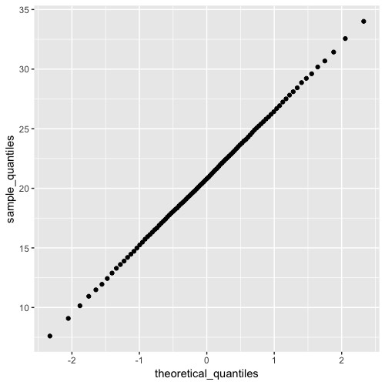

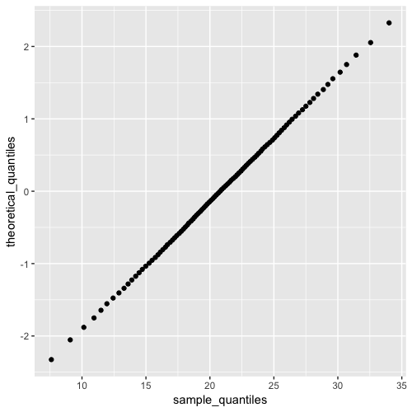

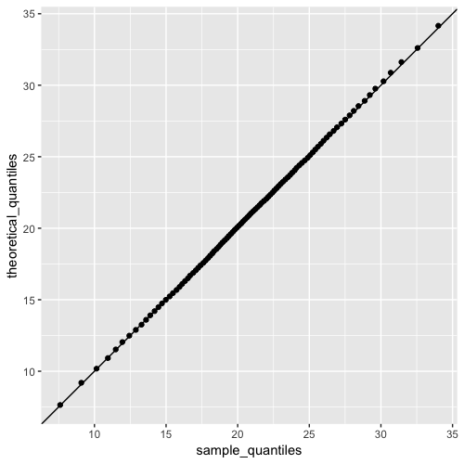

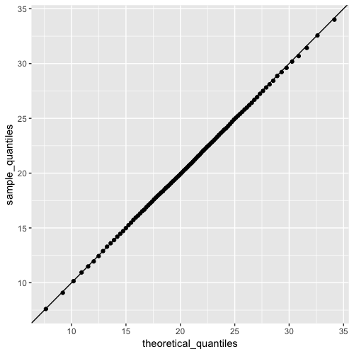

correct

You have used 1 of 2 attempts Some problems have options such as save, reset, hints, or show answer. These options follow the Submit button.